Day59&60 - Task29 - ECS

1. Setup a highly available ecs cluster with load balancer and dynamic port mapping.
NOTE:
Your cluster should maintain atleast 6 tasks at any point of time and should be highly availble across multiple AZ's.
Use the below image from deployment:
sabair0509/hiring-app:works
1. Create a VPC
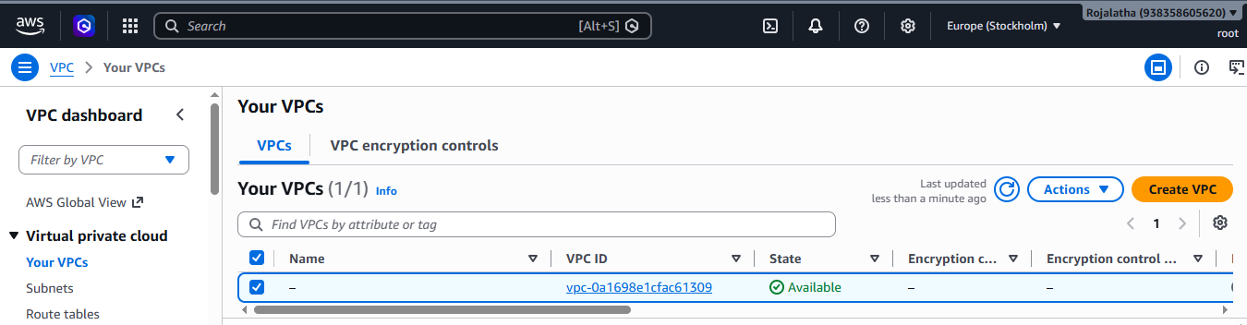
Using 3 subnets in different Availability Zones:
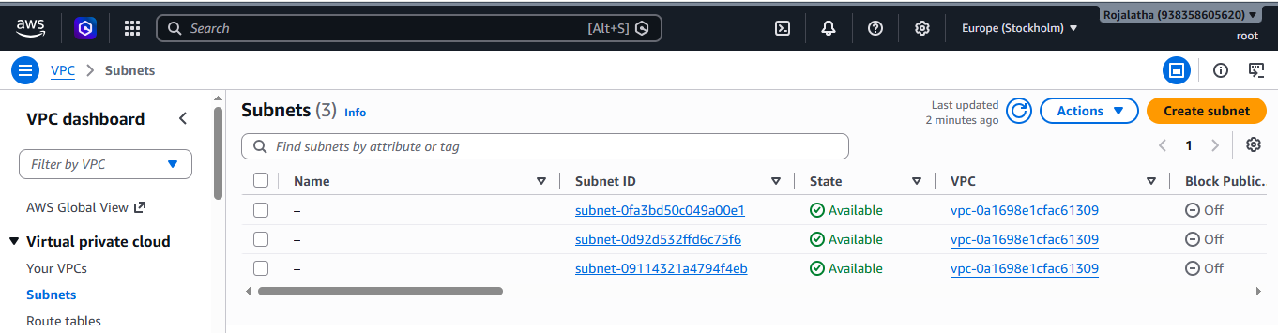
Attach Internet Gateway to VPC:
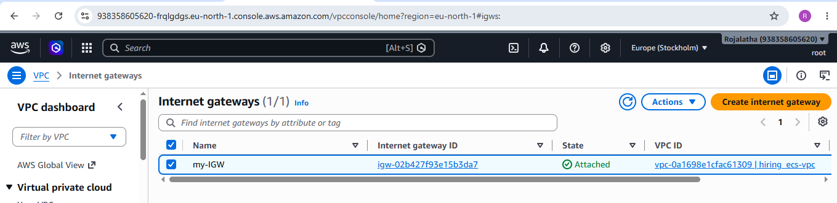

Edit subnet associations:
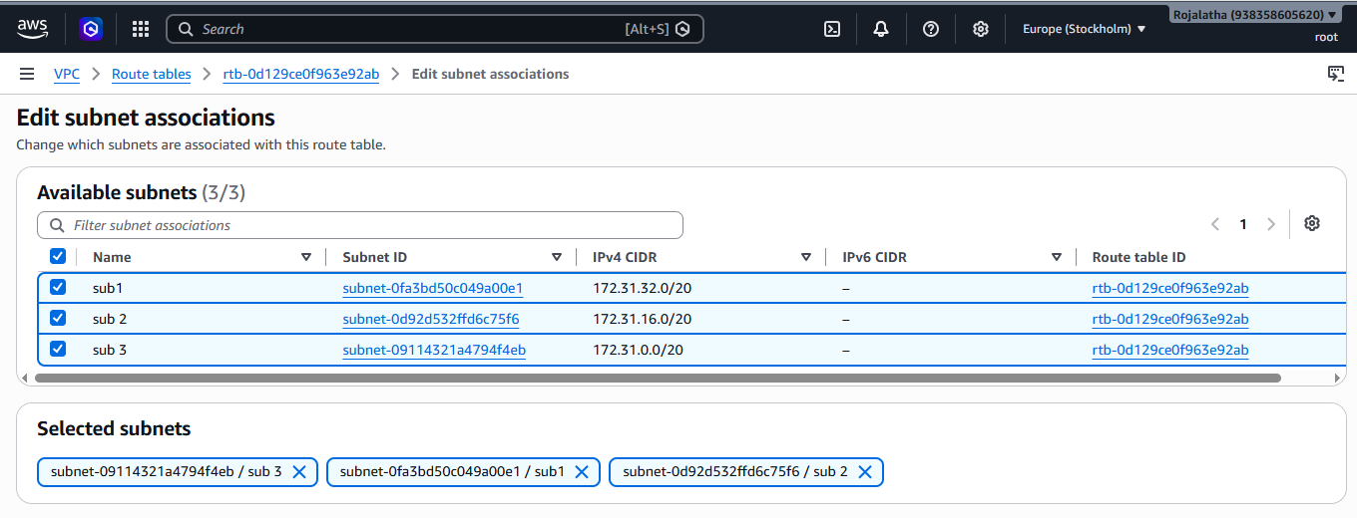
Enable auto assign Public IPV4:
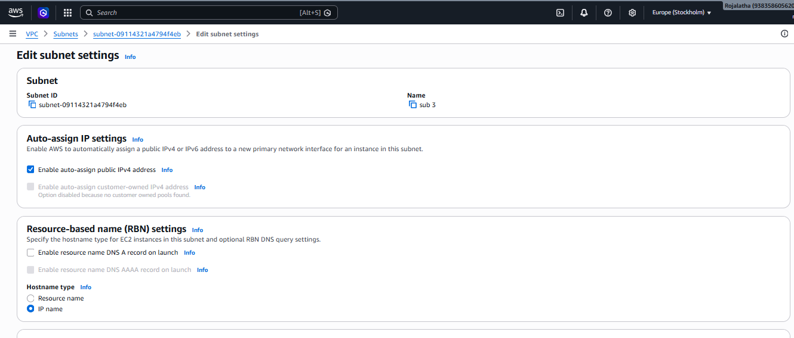
STEP 7: Create ECS EC2 IAM Role
Go to: IAM → Roles → Create role
Trusted entity: AWS service
Use case: EC2
Attach: AmazonEC2ContainerServiceforEC2Role
Name: ecsInstanceRole

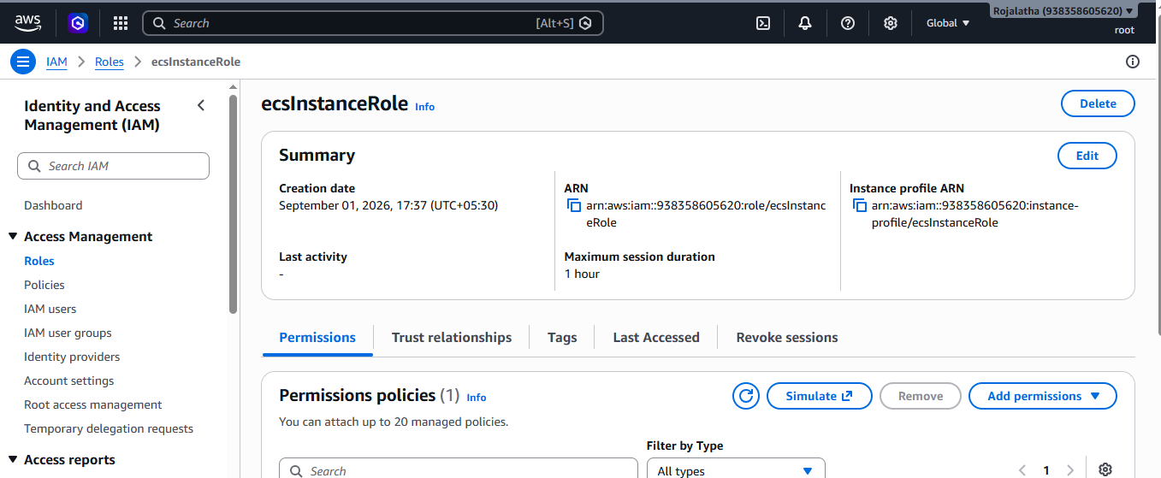
STEP 8: Create Security Group for ECS EC2 Instances
Create another security group: ecs-instance-sg
For dynamic port mapping, the ALB needs to reach the dynamically assigned host ports.
Add:
Type Port Range Source
Custom TCP 32768-65535 ecs-alb-sg
You can optionally add SSH while troubleshooting:
SSH
22
My IP
Do not expose the dynamic port range directly to: 0.0.0.0/0
Use the ALB security group as the source.
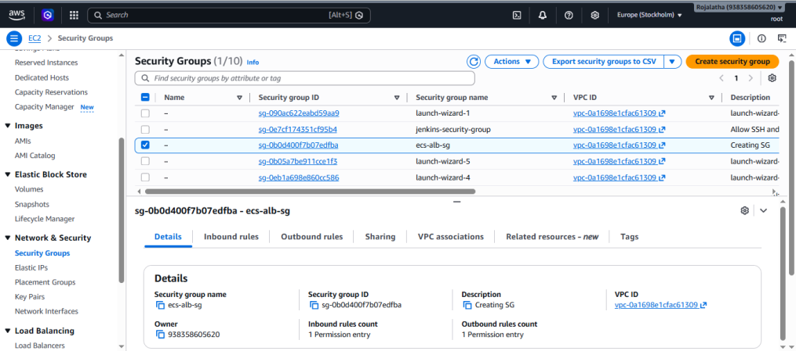
STEP 9: Create ALB Security Group
Go to: EC2→ Security Groups→ Create security group
Enter: Name: hiring-alb-sg
VPC: hiring-ecs-vpc
Add inbound rule:
Type Port Source
HTTP 80 0.0.0.0/0
Optional HTTPS:
Type Port Source
HTTPS 443 0.0.0.0/0
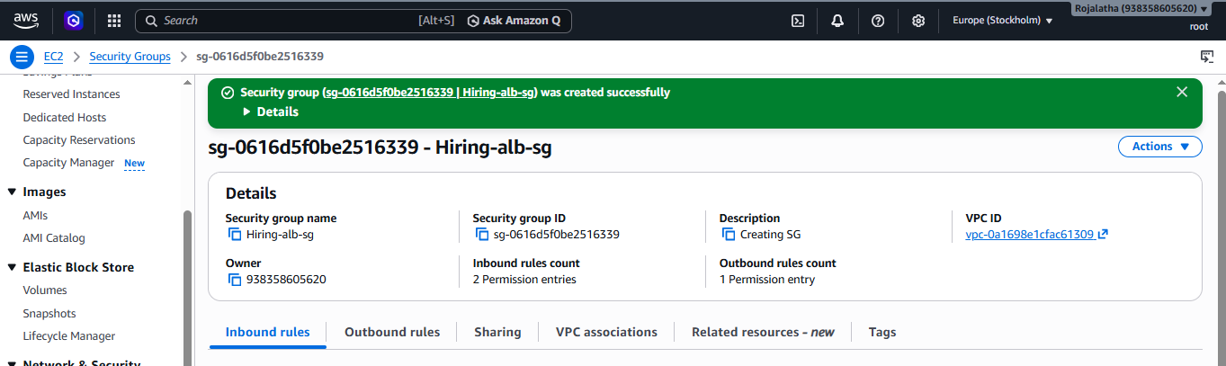

STEP 10: Update ECS Instance Security Group
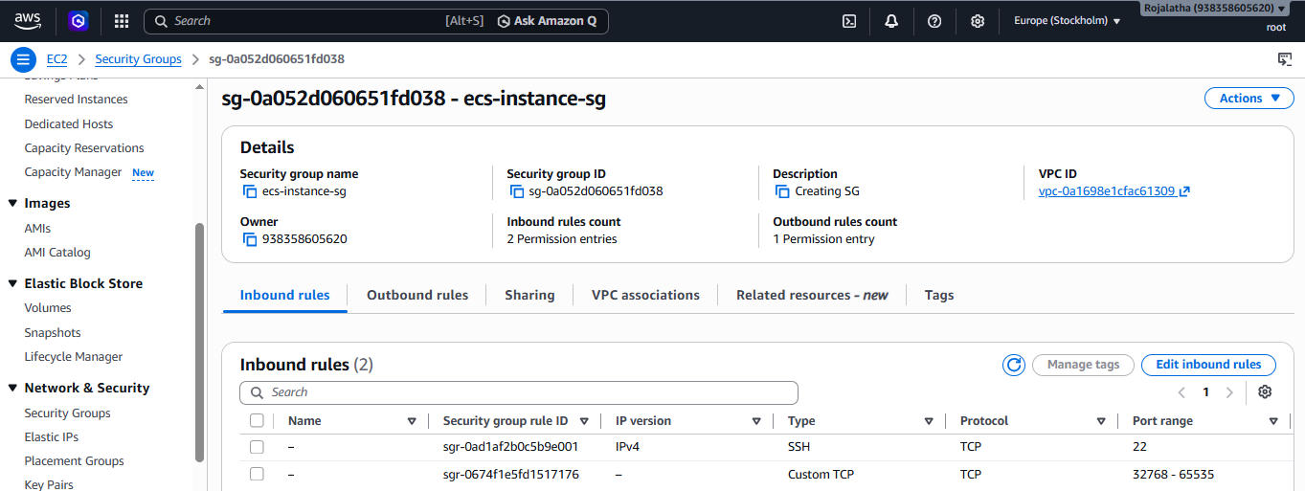
STEP 11: Create ECS Cluster
Now go to: ECS → Clusters → Create cluster
Cluster name: hiring-app-cluster
For infrastructure choose: Amazon EC2 instances
Depending on the current ECS console, AWS may offer to create EC2 infrastructure automatically. Since you already created an ASG, you can use a capacity provider with your existing ASG.
Create the cluster.
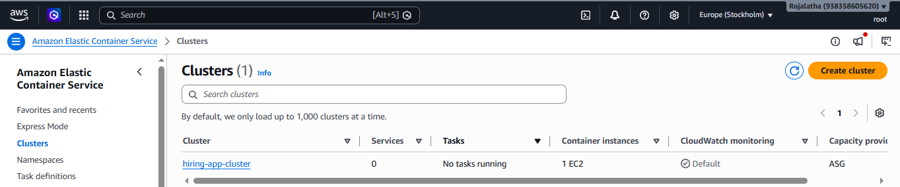
Step 12: Configure ECS EC2 capacity
For the practice environment, configure approximately:
EC2 instance type: t3.medium
Minimum: 4
Desired: 4
Maximum: 6
Why 4?
We want:
AZ-A: EC2 #1 EC2 #2
AZ-B: EC2 #3 EC2 #4
This gives us capacity across two AZs.
You can use a larger instance if the application consumes significant CPU/RAM.
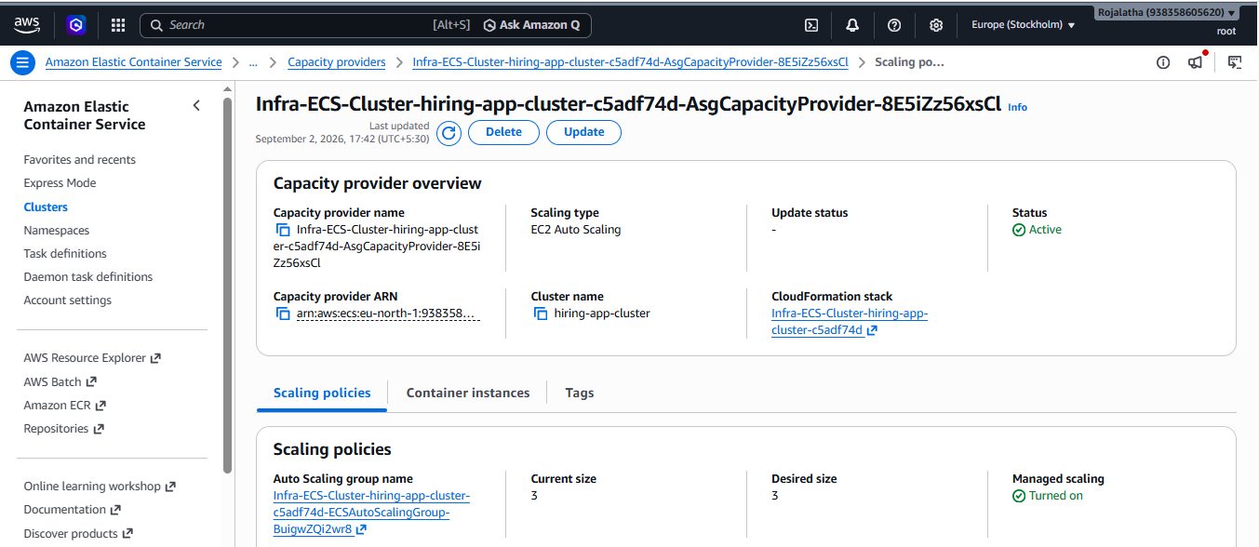
12. ECS container instances
After the cluster is created, go to: ECS → Clusters → hiring-ecs-cluster → Infrastructure
You should eventually see your EC2 instances.
You want approximately:
EC2 Instance
|
+-- ECS Agent
|
+-- Docker
|
+-- ECS Tasks
The ECS-optimized AMI already contains the components needed to run ECS workloads.
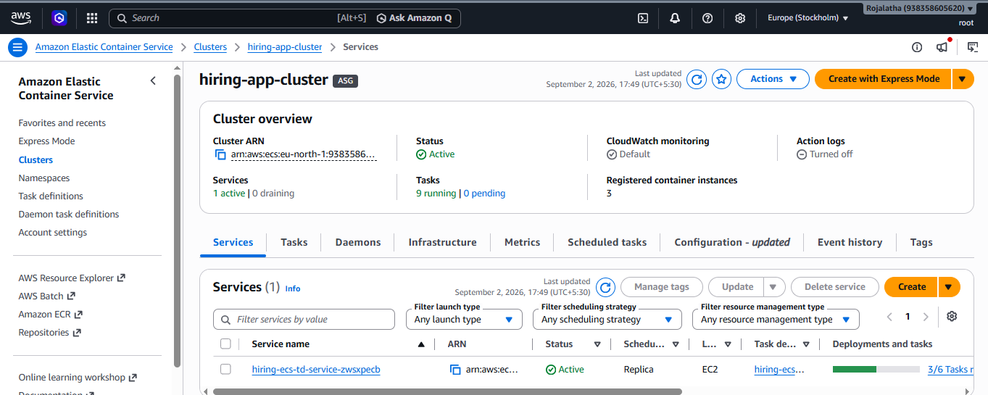
13. Verify ECS EC2 instances
Go to: ECS → Clusters → hiring-ecs-cluster → Infrastructure
You should see:
Container instances: 4
They should be: ACTIVE
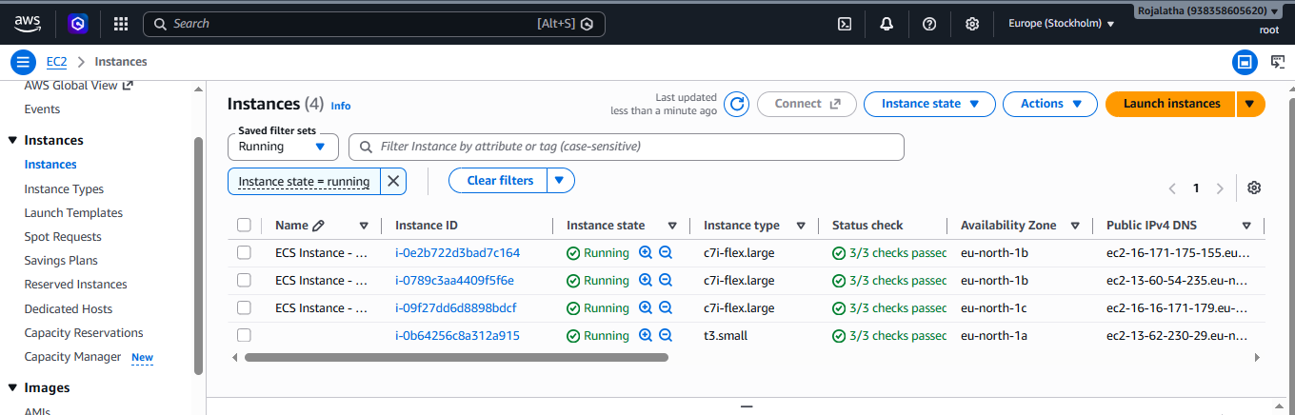
You can also SSH into an instance and check:
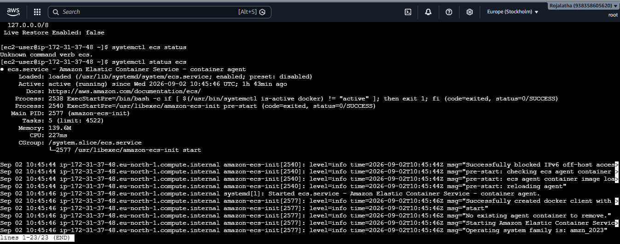
14. Step 6 — Create ECS Task Definition
Now create the actual application definition.
Go to: ECS → Task Definitions
Click: Create new task definition
Choose:
Launch type: EC2
Task definition name: hiring-task
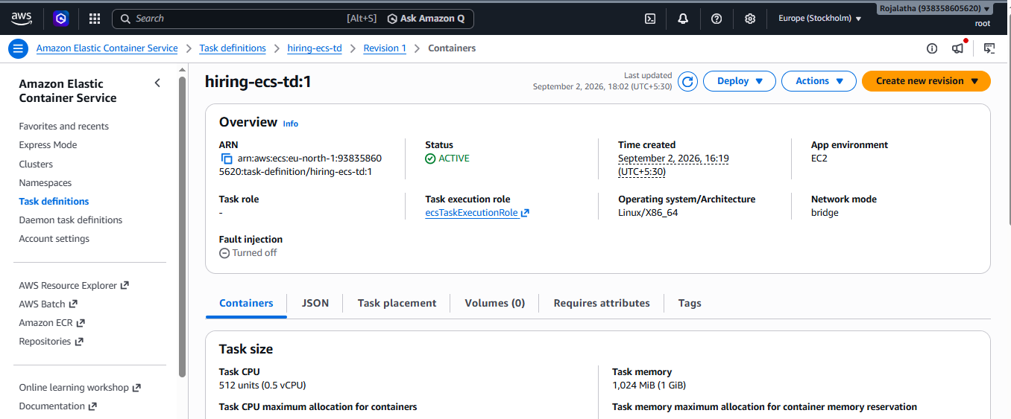
16. Add container
Container name: hiring-app
Image: sabair0509/hiring-app:works
This is the image specified in your question.
17. Configure port mapping
This is the most important part.
Suppose the application listens on: 8080
Configure:
Container port: 8080
Host port: 0
Protocol: TCP
So:
Container Port = 8080
Host Port = 0
Do not enter 8080 for Host Port.
Use: 0
This enables dynamic host port mapping.
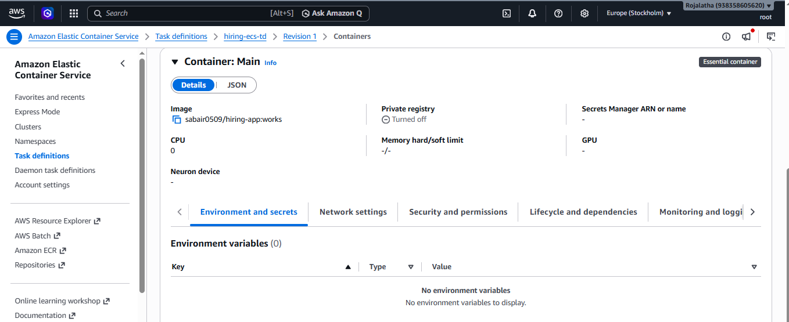
18. How the mapping will look
Suppose ECS starts 6 tasks.
You may see something like:
Task 1
Container: 8080
Host: 32768
Task 2
Container: 8080
Host: 32769
Task 3
Container: 8080
Host: 32770
Task 4
Container: 8080
Host: 32771
Task 5
Container: 8080
Host: 32772
Task 6
Container: 8080
Host: 32773
The actual ports will be automatically selected and may differ.
19. Create the task definition
Click: Create
You now have:
hiring-task
|
└── hiring-app
|
└── sabair0509/hiring-app:works
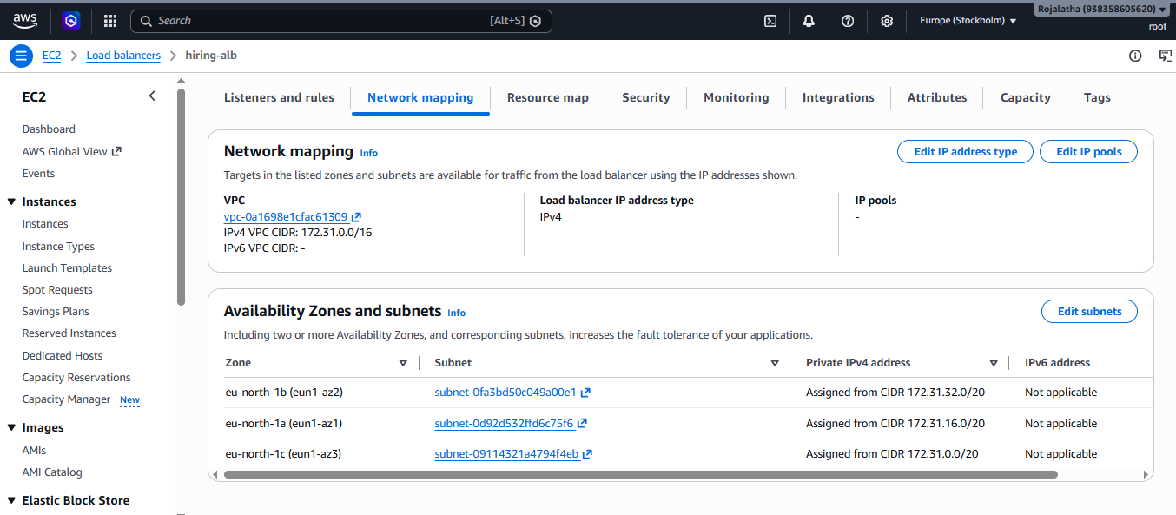
20. Step 7 — Create Application Load Balancer
Go to: EC2 → Load Balancers
Click: Create Load Balancer
Select: Application Load Balancer
Name: hiring-alb
Scheme: Internet-facing
IP address type: IPv4
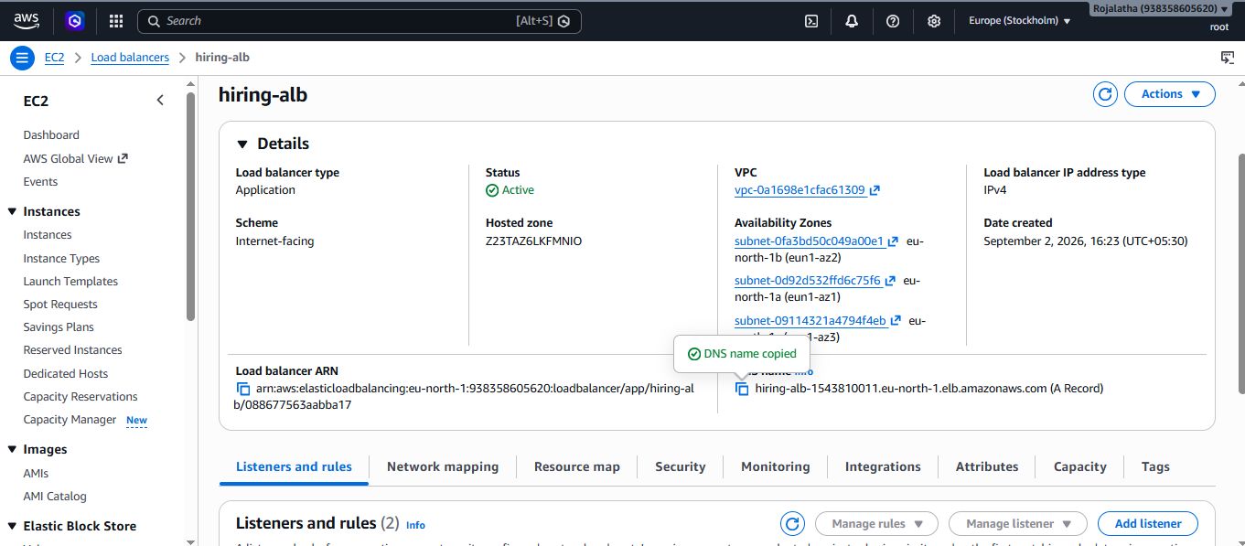
21. Select VPC and AZs
Select: VPC: hiring-vpc
Select:
AZ-A
Public subnet 10.0.1.0/24
AZ-B
Public subnet 10.0.2.0/24
This makes the ALB highly available across multiple AZs.
22. ALB security group
Select:
hiring-alb-sg
Listener:
HTTP : 80
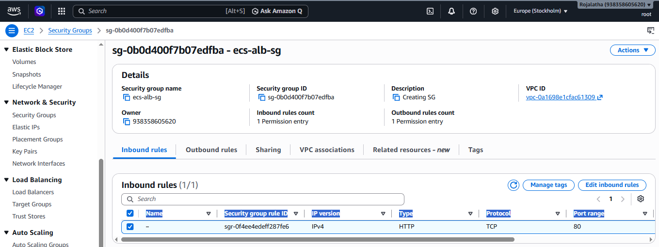
Create a target group.
Target type: Instances
This is important for the classic ECS EC2 + bridge networking dynamic-port setup.
Name: hiring-tg
Protocol: HTTP
Port: 8080
Health check:
Protocol: HTTP
Path: /
But remember:
The target group port is not necessarily the final host port.
ECS will register each task using its dynamically allocated host port.
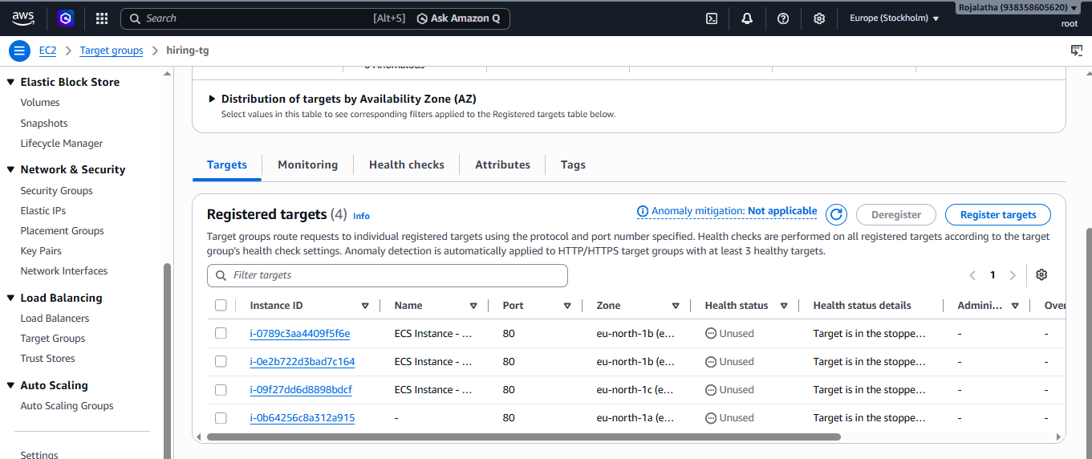
24. Example target group
After ECS starts the tasks, you might see:
Instance Port Health
EC2 #1 32768 Healthy
EC2 #1 32769 Healthy
EC2 #2 32770 Healthy
EC2 #3 32771 Healthy
EC2 #3 32772 Healthy
EC2 #4 32773 Healthy
Notice that all containers listen on: 8080 inside the container.
But the EC2 host ports are different.
That is dynamic port mapping.
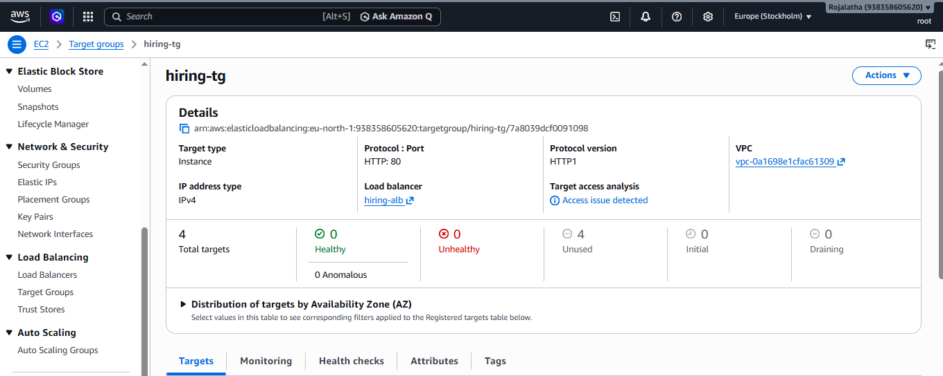

25. Step 8 — Create ECS Service
Go back to: ECS → Clusters → hiring-ecs-cluster
Click: Create → Service
Compute option:
Launch type: EC2
Task definition: hiring-task
Service name: hiring-service
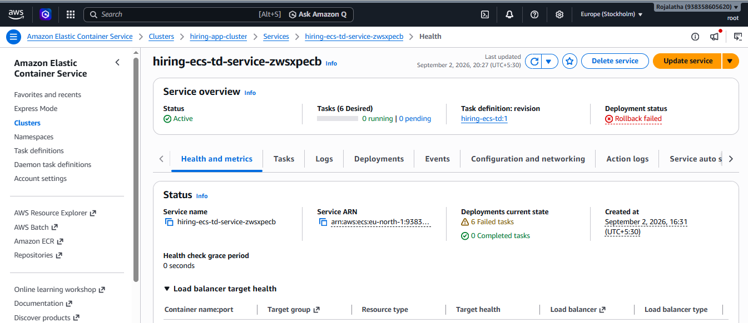
26. Set desired number of tasks
Set:
Desired tasks: 6
This is one of the most important requirements.
You should see:
Desired: 6
Running: 6
Pending: 0
Your service will try to maintain six running tasks.
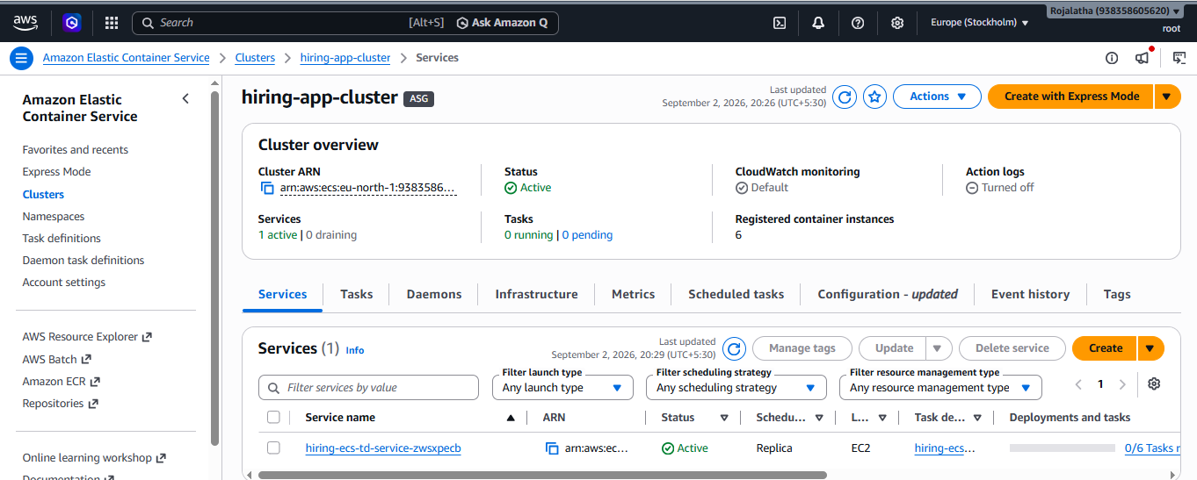
27. Deployment configuration
Use:
Deployment type:
Rolling update
For a simple lab, you can use:
Minimum healthy percentage:
100%
Maximum percentage:
200%
This allows ECS to launch replacement tasks before stopping old tasks during deployments,
subject to available capacity.
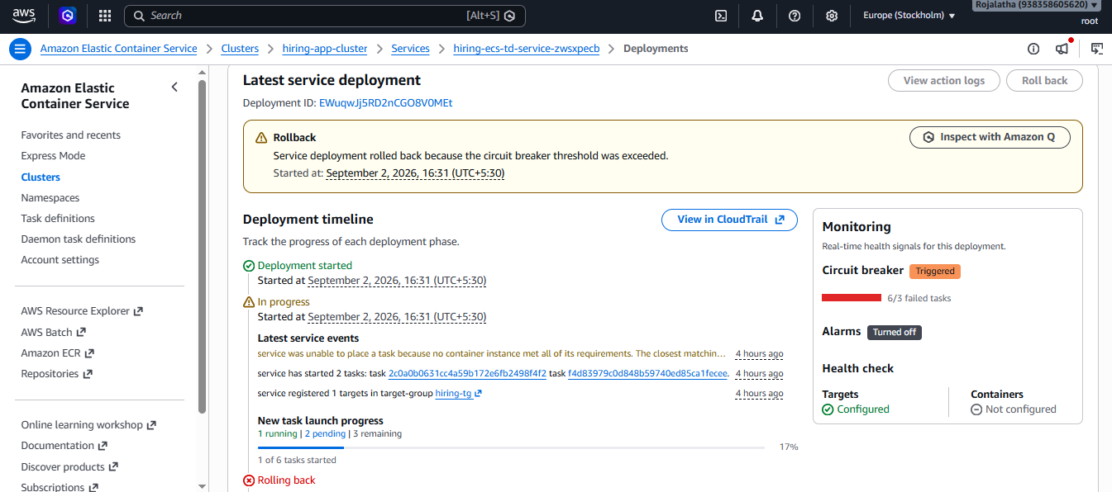

28. Configure Load Balancing
Enable: Use load balancing
Load balancer: Application Load Balancer
Select: hiring-alb
Listener:
HTTP : 80
Target group: hiring-tg
Container: hiring-app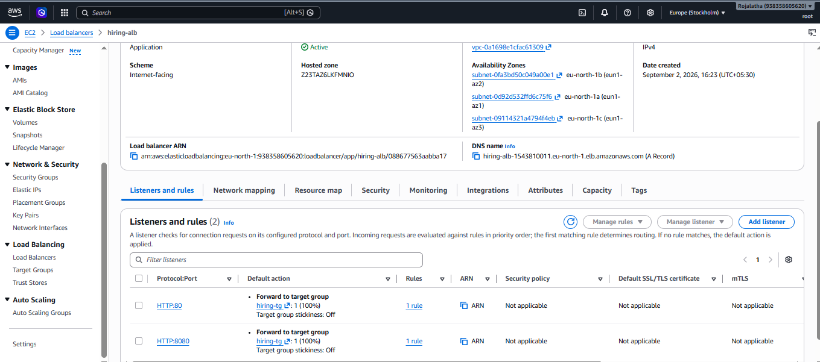
Port: 8080
ECS will associate the service's tasks with the ALB target group.

29. Verify Configure health check
Use:
Health check path:
/
For example:
Protocol: HTTP
Port: Traffic port
The ALB will check each task.
If a task becomes unhealthy:
ALB
↓
Unhealthy task
↓
ECS detects/replaces task
↓
New task starts
↓
ALB registers new task
Enable Auto Scaling
Minimum tasks: 6
Maximum tasks: 8
• Policy: Target Tracking
• Metric: ECSServiceAverageCPUUtilization
• Target:70%

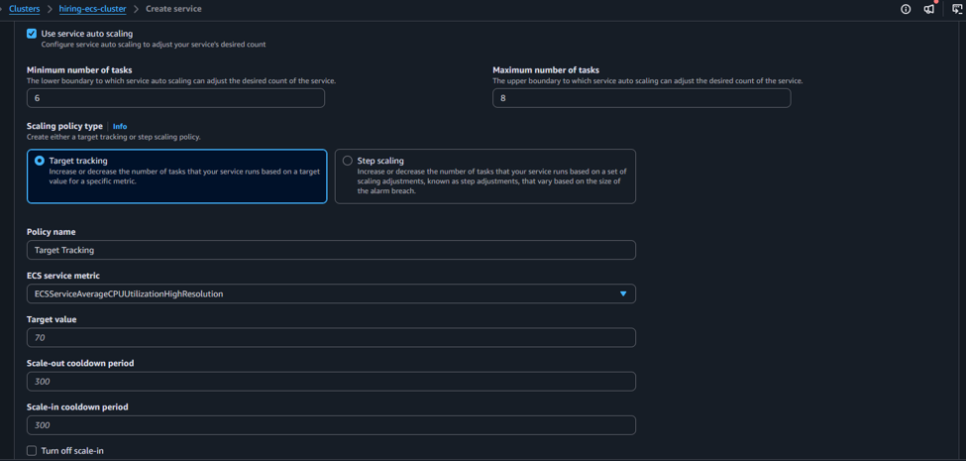

30. Verify the Configure service placement
This is important for your high availability requirement.
Configure ECS task placement so tasks are spread across Availability Zones/container instances.
Use a placement strategy such as: Spread
attribute: ecs.availability-zone
You can also use: Spread
attribute: ecs.instance-id
The objective is to avoid putting all six tasks on one EC2 instance/AZ.
For example:
AZ-A
EC2 #1
Task 1
Task 2
EC2 #2
Task 3
AZ-B
EC2 #3
Task 4
EC2 #4
Task 5
Task 6
A better distribution could be:
AZ-A
Task 1
Task 2
Task 3
AZ-B
Task 4
Task 5
Task 6
The exact placement is controlled by ECS scheduling and available resources.

31. Create the service
Click:
Create
ECS will now:
1. Find EC2 container instances
2. Pull sabair0509/hiring-app:works
3. Start containers
4. Assign dynamic host ports
5. Register tasks with target group
6. ALB performs health checks
7. Route traffic to healthy tasks
32. Verify the Check ECS service
Go to:
ECS → Cluster → hiring-ecs-cluster → Services → hiring-service
You should see:
Desired tasks: 6
Running tasks: 6
Pending tasks: 0
If you see:
Desired: 6
Running: 6
your main requirement is satisfied.
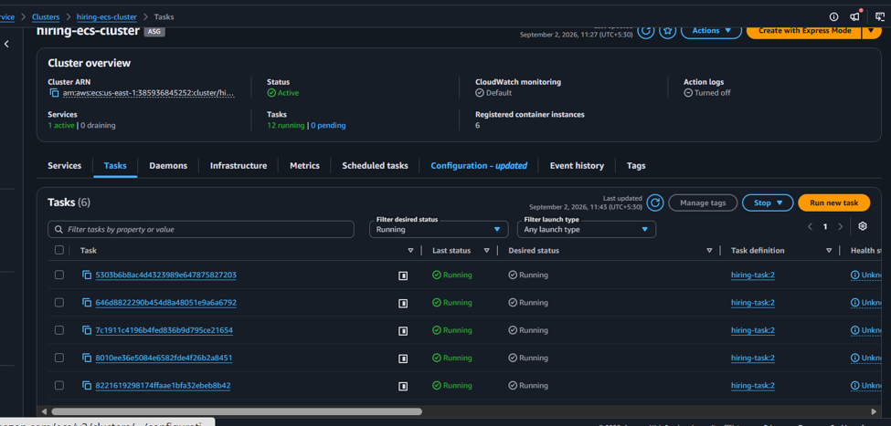
33. Check individual tasks
Click:
Tasks
You should see six tasks:
Task 1 RUNNING
Task 2 RUNNING
Task 3 RUNNING
Task 4 RUNNING
Task 5 RUNNING
Task 6 RUNNING
Click a task.
Look under:
Network bindings
You should see something similar to:
Container port: 8080
Host port: 32768
Another task:
Container port: 8080
Host port: 32769
Another:
Container port: 8080
Host port: 32770
This proves dynamic port mapping is working.
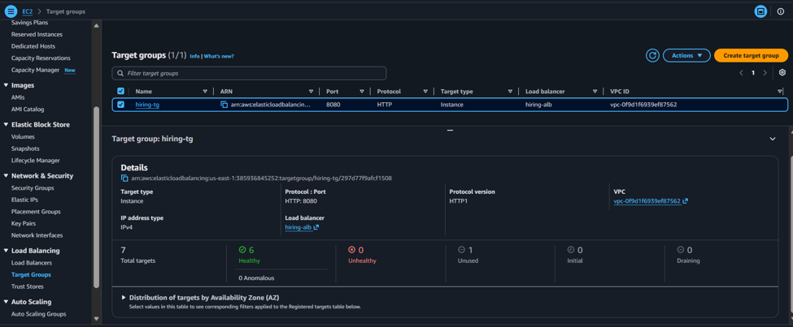
35. Test the application
Go to:
EC2 → Load Balancers → hiring-alb
Copy:
DNS name
It will look similar to:
hiring-alb-1450412887.us-east-1.elb.amazonaws.com
Open
hiring-alb-1450412887.us-east-1.elb.amazonaws.com
Your hiring application should appear.

